**EMERALDS**

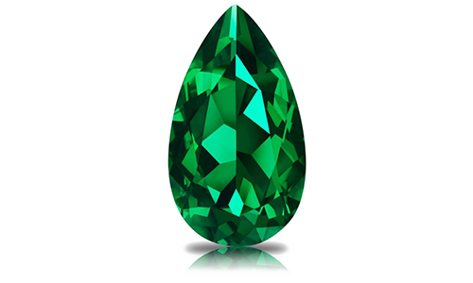

Emeralds are made of the mineral beryl, while diamonds are made of carbon. Diamonds are harder, are most colorless, and have yellowish hues; emeralds are not that hard and are mostly green or bluish-green.

Emerald cut diamonds have step-cut facets, which are long and rectangular, while round cut diamonds have triangular-shaped facets. Emerald cut diamonds have step-cut facets, which are long and rectangular, while round cut diamonds have triangular-shaped facets.

Emerald-cut diamond rings are timelessly beautiful. Though this diamond shape originated from the earliest cut of gemstones, the table cut, in the 1500s, it’s still widely popular and regarded as a modern style. Emerald-cut diamond engagement rings became especially chic in the 1920s and 1930s with the rise of Art Deco, a French-inspired style movement with geometric allure.

Surprising Facts About Emerald: May Birthstone

Emeralds are Not Always 'Emerald Green'

For Emeralds, the Cut is the Key!

Emeralds are Rarer and Often More Expensive than Diamonds.

Emeralds are the "Go-To" Gem for the Royal Set.

Emeralds May Give You More Bang for Your Buck than Diamond.